# Development Iterations

## 01 — From a Magic Wand to a Light Hourglass

At the beginning, I wanted to make a magic wand that could control the classroom lights through rotation and waving. I thought this interaction was interesting because the movement of a small object could create a response in the surrounding space.
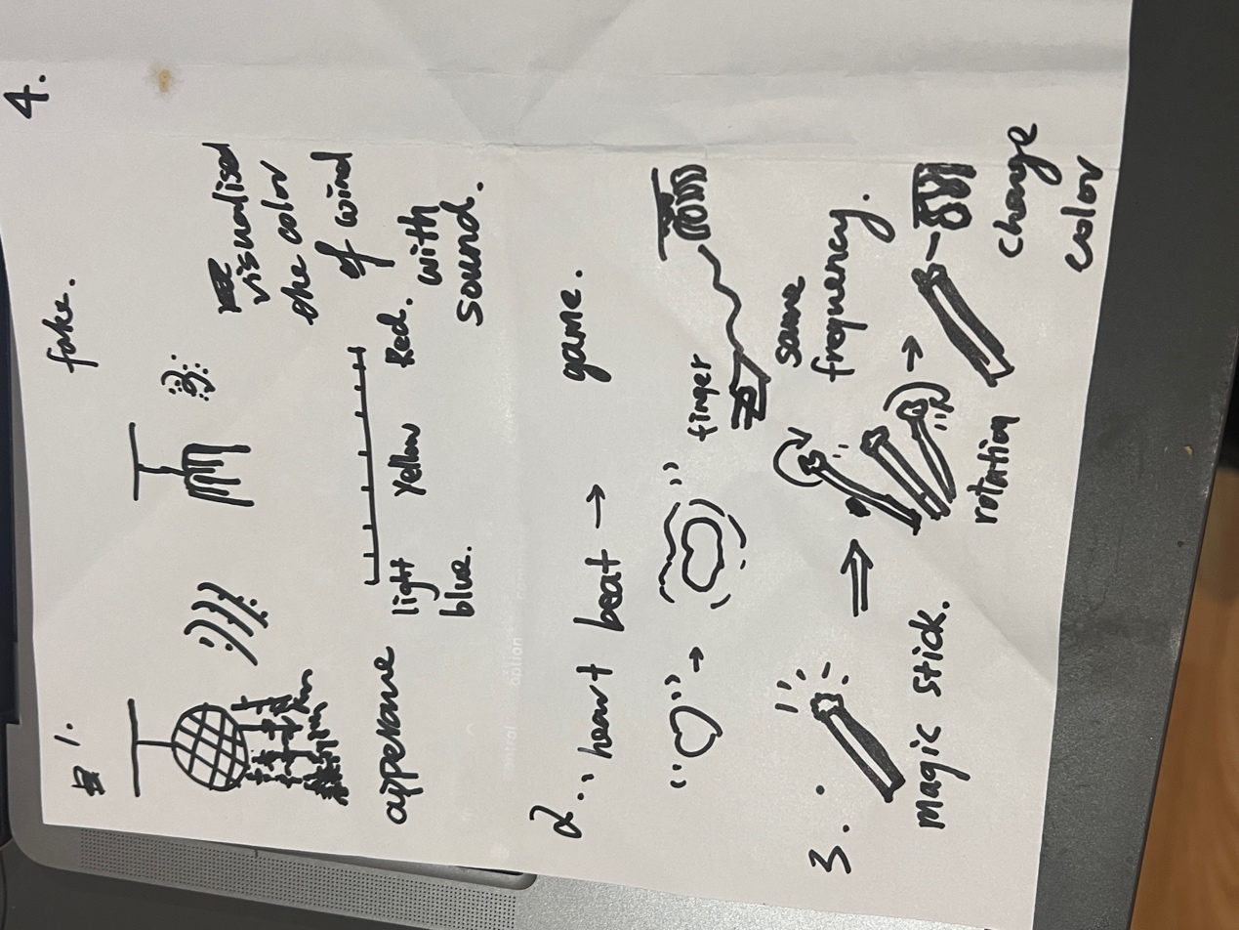
However, the available hardware made this more difficult than I expected. I had rotary sensors, but turning a knob is different from detecting the movement of the whole wand. I did not want to give up the idea completely, so I started looking for another object that could keep the connection between movement and light.
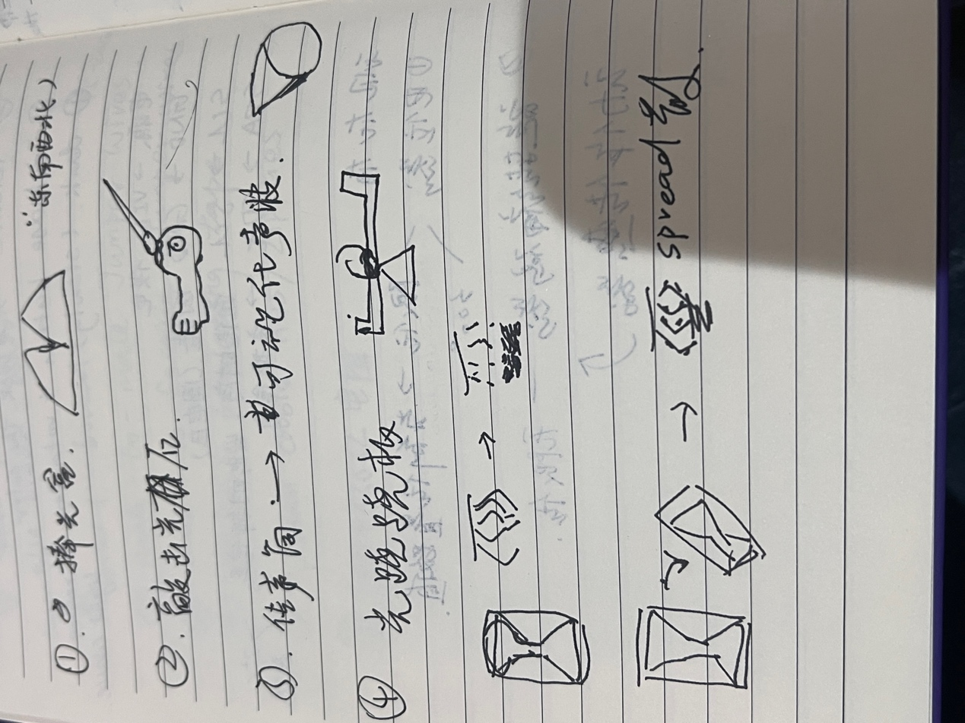

Then I noticed that the shape of Vespera, the classroom light installation, reminded me of an hourglass. An hourglass also has a clear physical action: turning it over starts the sand moving in the opposite direction. This gave me a way to continue exploring movement as an input while changing the form of the project.

I also started thinking about why this project was necessary. We already have digital clocks and phone timers, so why would we still use such an old way of measuring time? I thought about situations such as brushing teeth or resting between exercise sets, when reaching for a phone or repeatedly setting a timer could interrupt the activity. A simple flip could make starting another interval quicker.

I was also interested in how time is usually shown through numbers. I wanted to try making its passage visible through moving light. Connecting light with the familiar action of an hourglass could make timing feel more playful and easier to engage with. This became the main idea: flip the object to change the flow, shake it to disturb the light, and use touch to control the timer.

## 02 — Starting with a Tilt Switch

My first task was to detect when the hourglass had been turned upside down. I started with a digital tilt module because it seemed like a simple way to distinguish between two positions.

I checked its output in the Arduino Serial Monitor. The module returned either 0 or 1, so I could use a stable change in its state to reverse the light animation. The early version used an 18-second transfer.

At first, this seemed enough for a basic hourglass. However, I also wanted the light to react when I shook the object. The tilt switch could not tell me which direction I was shaking or how strong the movement was. Its output could change quickly because of the contacts inside it, which also made the readings harder to interpret.

Later, one of the module's pins broke. I needed another sensor, and this became an opportunity to find one that could support both flipping and shaking.

## 03 — Getting the Accelerometer to Work

I found a Grove three-axis digital accelerometer based on the MMA7660. It could provide X, Y and Z acceleration readings, which gave me more information than the tilt switch. Its measurement range is approximately ±1.5 g.

As a beginner, I found the connection more confusing than I expected. The Grove connector was smaller than my jumper connectors, and I also had to understand which pins on the Arduino were used for communication.

The connections were:

| MMA7660 connection | MKR WiFi 1010 connection |
|---|---|
| VCC | 3.3 V / VCC |
| GND | GND |
| SDA | D11 / SDA |
| SCL | D12 / SCL |

I installed the Seeed MMA7660 library and ran its example program. The first readings were 0 on every axis. I initially did not know whether this meant the sensor was working, but a stationary accelerometer should still detect gravity. After checking and correcting the data connections, the readings started changing.

For example, one stationary reading was approximately −0.10 g, −0.19 g and 1.05 g. When I tilted or turned the sensor over, the values changed across the three axes. This showed that I could use the sensor to develop the movement interaction.

I also noticed that strong movements could reach the sensor's limit. I decided that the project did not need to reproduce the exact movement of real sand. It only needed a clear visual disturbance when the object was shaken.
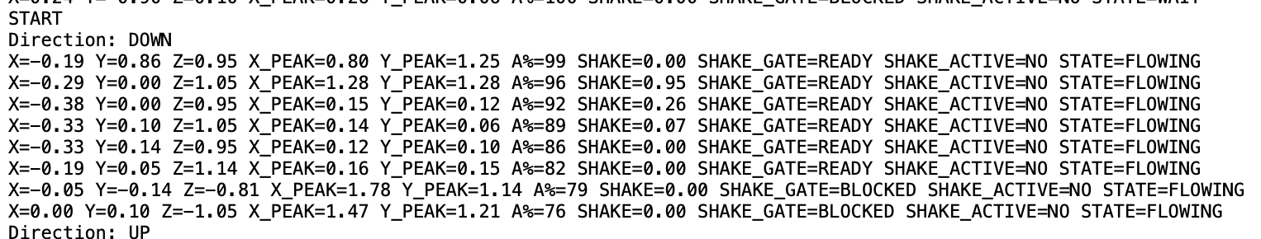
## 04 — Testing the Connection to the Lights

Once the sensor readings were working, I needed to check whether the Arduino could send colours to the lighting system. I used Wi-Fi and MQTT to publish the light data to:

```text
student/CASA0014/luminaire/29
```

I started with the web simulator so that I could see the output while developing the program. It has 72 cells arranged in 12 columns and 6 rows. Each cell represents an LED, and the numbering follows:

```text
LED index = column × 6 + row
```

Each LED has red, green and blue values, so a complete frame contains 216 bytes.

For the first test, I sent a red colour to LED 0. When the top-left cell turned red, I could see that the communication and that part of the numbering were working.

This made the simulator useful for checking the animation before testing it on the classroom installation. However, I still needed to check how the rectangular web grid corresponded to the physical arrangement of Vespera, because the same pattern could look different on the actual lamp.

## 05 — Making the First Falling-Light Effect

The first animation followed a simple hourglass idea: light at one end gradually decreased while light at the other end increased. Between them, moving particles represented the falling sand. Turning the object over changed the direction of the transfer.
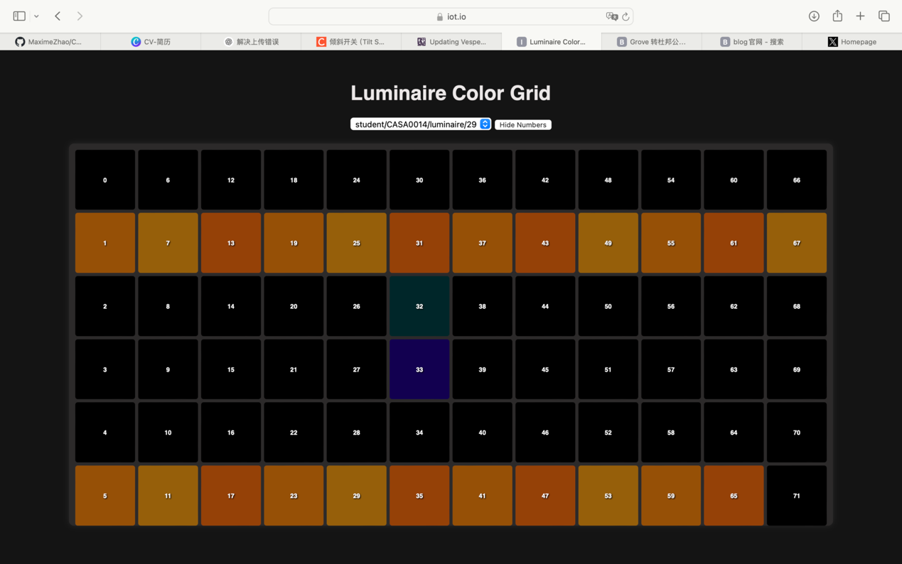
The effect started to work, but I noticed that most of the falling light stayed around LEDs 32, 33, 38 and 39. Only the middle of the display was active, which made the movement feel too limited.

I wanted more of the display to take part. Instead of one narrow stream, I wanted the particles to fall along different paths and gradually gather at the lower end. This led me to change both the distribution of the particles and their colours.

## 06 — Making the Sand More Colourful

The early light effect mainly used orange. I thought the falling sand would be more interesting if its colour changed while it moved, then became orange after it settled. This would also make the difference between movement and accumulation easier to see.

I changed the falling particles to a rainbow palette and spread their paths across more columns. I also increased the amount of sand participating in the animation. The revised program uses 30 simulated grains, with a flight window of approximately 12 grains.
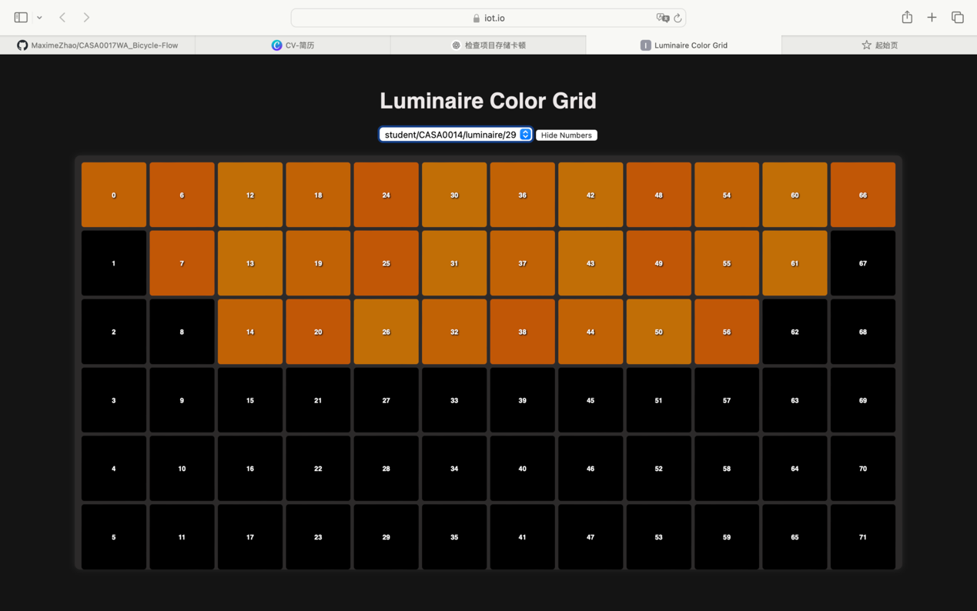
Brightness was another part of the effect. I wanted the falling particles to look softer and the settled sand to look brighter. The falling colour values were capped at 155, while the red channel of the settled orange could reach 255 at the default master brightness.

I also changed the full transfer time to 30 seconds for the demonstration. The wider movement and the change to orange made the process of falling and settling clearer to me.

The display still has only 72 cells, so several particles can appear in the same cell. I treated this as a visual representation of sand rather than trying to make every grain behave exactly like real sand.

## 07 — Making Shaking and Flipping Feel Different

I wanted two different responses from the same sensor. A flip should reverse the flow, while shaking from side to side should disturb the light.

This was harder than I expected. At first, the program was too sensitive, and even a small movement could trigger the shaking effect. After making the detection stricter, I had the opposite problem: the shaking became less obvious, and sometimes turning the object over did not work reliably either.

I also found that a normal flip could trigger the disturbance effect. To me, these were different actions, but both changed the acceleration readings. I had to adjust how the program decided what movement had happened.

I worked through changes to the movement thresholds, checks for back-and-forth motion, and confirmation of the opposite orientation. Instead of reversing the flow from one changing reading, the program required a confirmed change in position. Readings near the sensor's limit were not enough on their own to confirm a flip.

During this process, I also had to decide what shaking should do to time. I chose to let it affect the appearance of the sand without resetting the countdown or making it run faster. Otherwise, playing with the object would change the interval the user was trying to measure.

The Serial Monitor helped me see when the shake detection was being blocked and when the readings were reaching approximately ±1.5 g. Finding a balance between sensitivity and false triggers became an important part of this stage. The way the object is held and moved still affects how clearly the gestures can be separated.

## 08 — Adding Touch as Another Interaction

After developing the movement response, I wanted another way to interact with the timer. I added a Grove Touch v1.1 module so that the user could make an intentional input without shaking or turning the object.

I connected it as follows:

| Touch connection | MKR WiFi 1010 connection |
|---|---|
| VCC | 3.3 V / VCC |
| GND | GND |
| SIG | D2 |
| NC | Unconnected |

The touch sensor and accelerometer shared power and ground through the breadboard. The accelerometer used SDA and SCL, while the touch sensor used its own digital input.

Before adding it to the full animation, I tested both sensors together. The Serial Monitor showed the acceleration readings alongside `TOUCH_RAW` and the filtered touch state.

At first, I saw many `TOUCH=OFF` readings and was unsure whether it was working. Later, I could see `TOUCH EVENT: ON` when I touched the pad and `TOUCH EVENT: OFF` when I released it. This confirmed that contact could be detected while the accelerometer was still updating.

The next question was what this touch should actually do in the project.

## 09 — Changing Touch from Breathing to Freezing Time

My first idea was to make the settled sand breathe when the user touched the sensor. Later, I thought breathing would work better as the effect that appeared automatically when the timer finished.

This left touch available for another function. I chose to use it to freeze time: touching the pad would stop both the moving light and the countdown, so the user could continue from the same point later.

The first version paused while I held the pad and was supposed to continue when I released it. However, resuming sometimes took too long. The program was waiting for a suitable orientation, and it could remain in `WAIT_POSE` when the object was tilted.

I wanted the touch response to feel immediate, so I removed this mandatory wait. The timer could continue in its existing direction, while a new flip would be checked separately. This made more sense to me because resuming and flipping were two different decisions.

## 10 — Changing from Holding to Tapping

After trying the freeze interaction, I realised that keeping a finger on the sensor was not the interaction I wanted. I wanted to touch it once, leave the timer paused, and touch it again when I was ready to continue.

The interaction became:

1. Tap once to freeze the light and countdown.
2. Remove the finger.
3. Tap again to continue from the same state.

The program needed to recognise a new touch rather than repeatedly react while the finger stayed on the pad. I changed the logic so that one press produced one change, and releasing the pad made it ready for the next press. Shortchanges in the signal were also filtered.

The revised program compiled for the MKR WiFi 1010, and a software test checked that one press caused only one toggle. I still needed to check the response after placing the sensor in the enclosure, because its position and wiring could affect how it felt to use.

At the end of the transfer, the orange sand breathes automatically. Touch is used to pause and resume during the transfer, while breathing marks its completion.

## 11 — Deciding to Keep USB Power

I originally wanted to use a battery so that the object could be carried and flipped without a cable. I had 3.7 V batteries available, but their connectors did not fit the board's battery socket.

I looked at ways to connect them, but I did not have the suitable connectors and tools to complete the connection reliably. I decided to leave battery power out of this prototype and continue with USB power.

I also kept the MKR WiFi 1010 on the breadboard because it already supported the connections for both sensors. The lighting commands are sent through Wi-Fi, but the controller still needs a USB cable for power.

This decision affected the next stage. I had to design around the cable instead of assuming that it would disappear inside the final object.

## 12 — Fitting the Hardware into the Enclosure

When I started making the enclosure, I wanted it to feel like an object I could hold and turn over, rather than a loose collection of components. I used cardboard and transparent sheet material to explore the shape.

The breadboard measured 82 × 55 mm, with the MKR WiFi 1010 fixed on it. However, I soon found that these measurements were not enough to decide the size of the shell. The jumper connectors, Grove cables and loops of wire also needed space.

I tried placing the board assembly on a sloped support to reduce the space it occupied at the bottom. Later, I wanted to keep the base I had already made and close two side panels over it, forming a triangular cross-section.

Some of the earlier panels did not close properly. This made me realise that I needed to fit the shell around the actual connected hardware, rather than only drawing a shape that looked suitable from the outside.

The USB position created another problem. If the connector faced downwards, the cable interfered with standing the object on that end. I considered rotating the whole breadboard assembly by 90 degrees so that the cable could leave through the left or right side. The accelerometer was mounted separately, so I could keep its position fixed while changing the position of the main board.

The remaining checks were whether the panels could close, whether the cable had enough clearance, and whether the object felt comfortable to hold. I also needed to secure the accelerometer so that it moved with the shell rather than shifting inside it. This stage showed me that the enclosure and the interaction had to be developed together, because the physical arrangement affected how the sensors and controls could be used.

